**Week 2 Lecturecast: Research Questions, the Literature Review and the Research Proposal**

**Understanding Research Questions**

Research Questions are clear, concise, arguable questions in which a research is focused on.

Research questions provide a path to guide the writer in the researching process.

**Importance of a Good research question**

* It defines the focus of your research project.
* It defines the data you need to collect and the analysis to be carried out. However, as you collect data, your research could grow.
* Developing research questions is an iterative process.

Mind maps are very helpful in forming a direction.

**Steps in developing a research question**

* Consider research you’ve already done
* List down the ideas from your previous research (written submissions or reports) and choose one or two that seem relevant to explore.
* Check current events or timely issues for promising research questions.

**Guidelines:**

* Start with a context that is relevant to you
* Choose an interestingly appropriate topic
* Do some general preliminary research on your topic
* Consider your audience

**Assessing your Working Research Questions**

* Is your research question clear?
* Is your research question focused?
* Is your research question complex?
* Is your research question feasible?
* Hypothesise

**The Critical Literature Review**

Involves reviewing literature that helps answer research questions or fulfil research objectives

**The Review Purpose, Searching and Evaluating Literature, and Citing and Referencing Sources**

The Review Purpose

We need to consider the strengths and limitations of literature that we are reviewing

Consider gaps in existing literature that could be exploited by your research project and develop research questions around the gaps that exist.

Literature being critiqued must be relevant and valuable to the research project.

Searching for Literature

Search for literature that already exists around this topic. We could search;

* Textbooks
* Database catalogs
* Indexes
* Reports
* Academic journals and textbooks

We need to stay away from weak sites.

Steps in searching and evaluating literature.

1. Consult literature that you are already aware of.
2. Systematically take notes of key points read and note reference details
3. Identify keywords used in the literature and key authors referred to.
4. Follow up on useful keywords, citations and points made in step 3.
5. Search physical and electronic resources for suitable literature
6. Access abstracts, titles, books, journals for relevance. Avoid weak sources
7. Move back to step 2
8. Be alert for new sources appearing in both physical and online libraries.

How to Structure a literature Review

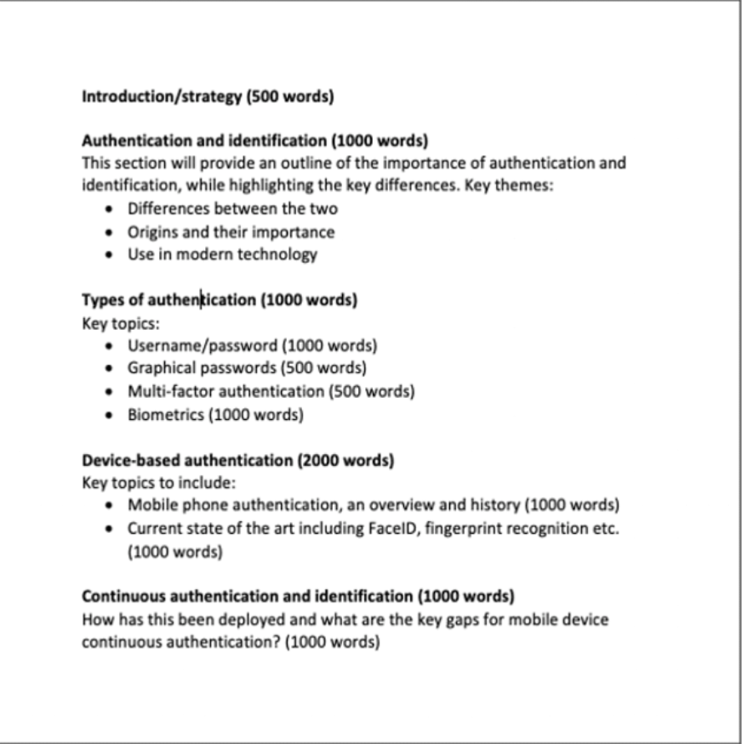

**Required Sections in Standard Proposal in the Computing Department**

* Project Title
* Significance/Contribution to the discipline/research problem
* Research question
* Aims and Objectives
* Key literature related to the Project
* Methodology/development Strategy/Research Design
* Ethical consideration and Risk Assessment
* Description of artefacts that will be created
* Timeline of proposed activities